WEEK 2
SPRING CORE AND MAVEN
LibraryApplication.java
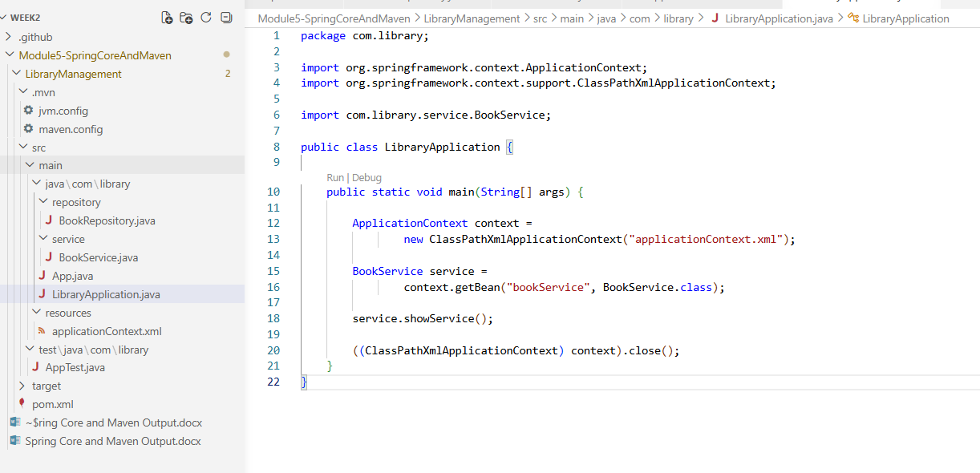
BookRepository.java
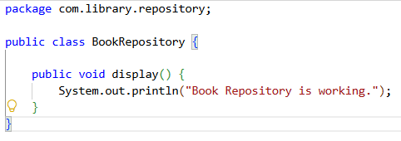
BookService.java
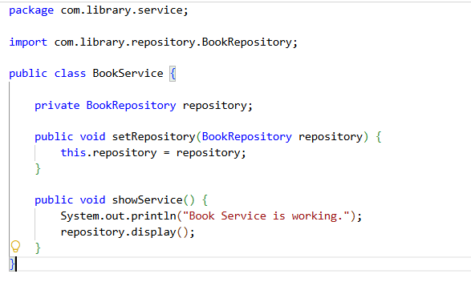
applicationContext.xml
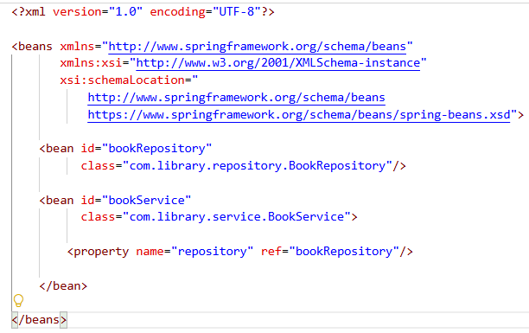
Output

Exercise 2: Implementing Dependency Injection
Modify the XML Configuration:
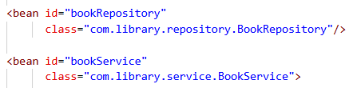
Update the BookService Class:
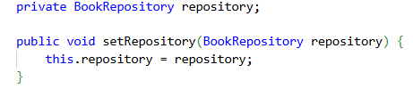
Test the Configuration:

Exercise 4: Creating and Configuring a Maven Project
Output
